***Abstract—Human-Computer Text-Based recognition is gaining thrust as a medium of computer interaction. It's being very important for new students to know about their college, as many students need help for solving their queries related to a college campus, canteens, classrooms, etc but college faculty or senior students are not able to reach out to every student and solve their problems related to college. This paper proposes a system architecture that will try to overcome the above problem by using an automated text-chatbot that will initiate text-based conversion among that customer(student) and help the customer for resolving the issue by providing a human way interaction. To provide a highly robust, scalable architecture, this system is implemented on AWS services like Amazon Lex.***

Keywords- Chatbot; Amazon Lex.

1. INTRODUCTION

Text-Based Chatbots have been intended to streamline the association among PCs and people and have hit the market.

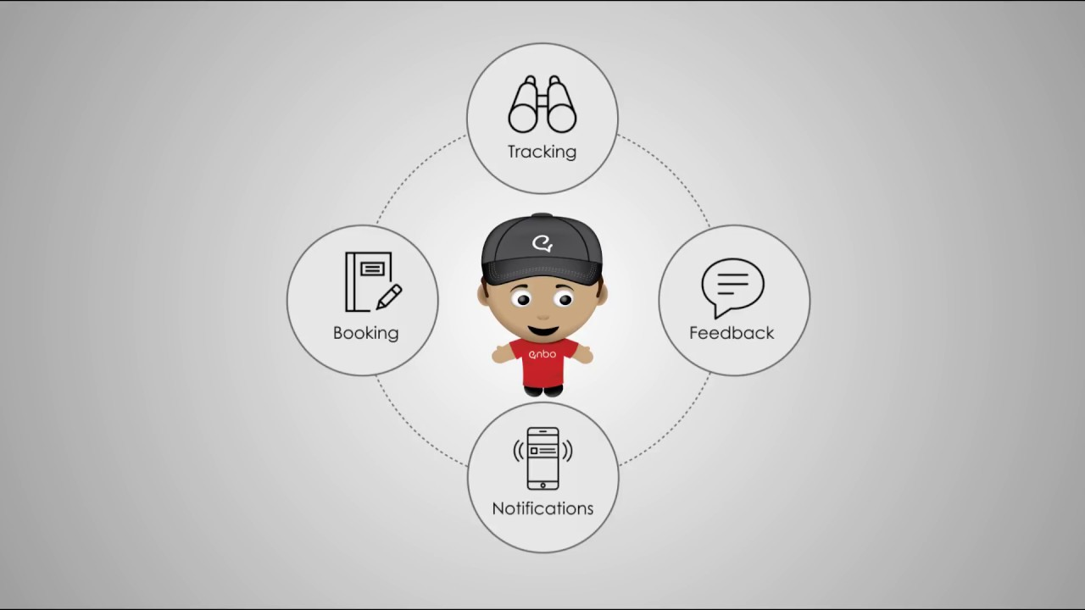A Text-Chatbot is a product that functions man-made ability that can speak (or talk in a text message) with a client in common language utilizing virtual talk rooms, sites, versatile operations and informing operations or through the phone. Text-Based Chatbots are frequently referred to as one of the most promising and propelled type of communication between machines and people. Figure.1 shows what the customer can do with text-chatbot.

Fig.1. What the customer can do with text chatbot.

Although, from a technological perspective, a text-chatbot will merely represent the evolution of a Question responsive system supported expressing transform. Generating question responses towards the customer(students) queries using Amazon lex is one of the easiest ways for various end-use applications. Text-Based Chatbot operations smoothly interact between services and other people, elaborating client expertise. At the same time, text-chatbots offer organizations(colleges) distinct chances to upgrade the client's(student) accuracy and guarantee operational effectiveness by limiting the surplus expense of client(student) support. Text-Based text-chatbot solutions ought to effectively perform each of the tasks for successful execution. Figure.2 shows how we use chatbots for the education system.

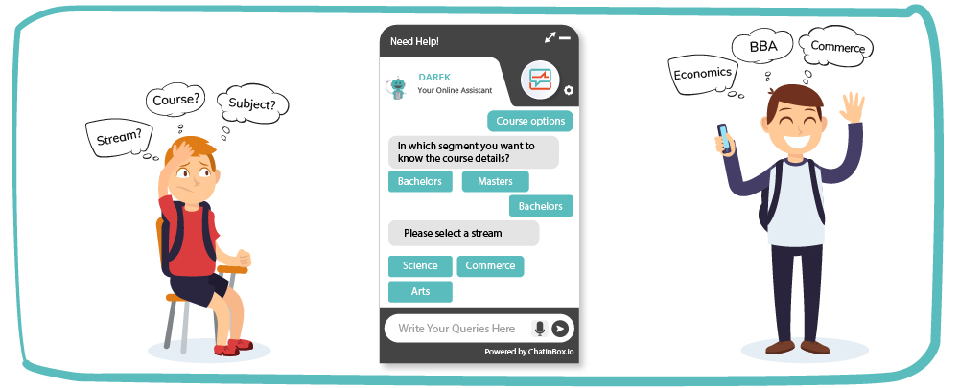 Fig.2. Text-Based Chatbot For Education

Human interruption plays an important role in teaching and building the whole text-chatbot system. Human teaches the text-chatbot about two different tasks:

1. How to investigate customer Request

2. What to reply.

How to investigate customer request: This is a fundamental duty that a text-chatbot performs after the customer request any advice. In this job, text-chatbot investigates the customer's(students) challenge and recognizes the customer's (student) goal to extract applicable elements. This quality of observing the customer's purpose and split information and applicable items Present in the customer's challenge in the first and essential condition and, the most critical track at the origin of a text-text-chatbot: If you miss to exactly recognize the customer's appeal, you will neglect to give the proper answer.

What to reply: At first the customer's goal is recognized furthermore when that is done, the text-chatbot can give the most appropriate reaction for the customer's question. A present question provoke the text-chatbot to adequately catch the customer's appeal. Text-Chatbot perhaps constructs by the usage of separate procedures. Contingent upon the operation you wish to address, some singular text-chatbot growth is more feasible than others.

**2. Problem Faced**

As a student, we faced many problems when we came to college as a new student and then we realized that it is very difficult for a new student to get a full conclusion about the college. In college, there are many challenges to be faced by new students like not aware of the college people, seniors, places, classrooms, canteens, faculty. Also, new student hesitates in asking their question and not solving their problem. New students are thinking that they are new, so, there is no one to solve their problem. If a new student is a hosteler, then it is tougher to face these challenges.

**3. The Proposed Solution**

As a student, we came up with the solution of text-chatbot. This proposed solution helps the new student in solving their queries. And of course, one person can't perform such a task(helping every student by reaching out one by one). So, we use one technology service, Amazon Lex, to construct a text-chatbot that helps students to solve their problems(or face their challenges related to college ) by assisting them in a return response through text messages.

**4. Service Related Theory**

**4.1 Amazon Lex system architecture**

Amazon which is used for constructing communicative interfaces for operations using text. Amazon system architecture works in a very simple way. When a customer requests their query it simply goes to the AWS container in which it passes through three stages:

1.Amazon Lex

2.AWS Lambda

3.Amazon DynamoDB Storage

Amazon Lex: Amazon Lex is a service provided by Amazon which is used for constructing communicative interfaces for operations using text. When any request comes to Amazon Lex, it simply passes it to AWS lambda.

AWS Lambda: AWS lambda validates the user by running the code in the background which is written in NodeJs, Python, React, etc. After validation, it fetches the information which is required to use from Amazon DynamoDB storage.

Amazon DynamoDB Storage: It is a database which is having all the information required for the customer.

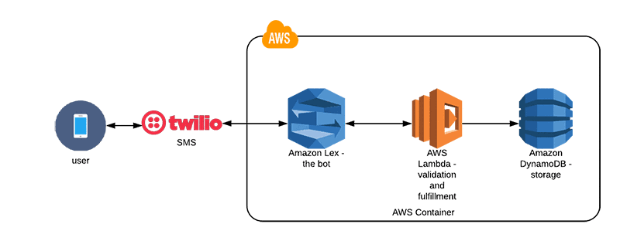

Fig.3. Amazon Lex Architecture

**4.2 Other Platforms For Chatbot**

There are few other platforms other than Amazon lex like Google, IBM, Microsoft which can provide services for constructing your chatbots. These services of other platforms are DialogFlow of Google, IBM Watson, Azure Bot services of Microsoft.

|  |  |  |  |  |
| --- | --- | --- | --- | --- |
|  | Amazon Lex | Google DialogFlow | IBM Watson | Azure Bot Services |
| Ease of use | Amazon lex offers a simple network interface for constructing a chatbot and it supports AWS Lambda for validation. | Google DialogFlow offers primitive bots to construct your bot and it needs improvement in their interface. | IBM Watson | Azure offers a smart text-chatbot but the customer cannot get access to new appearance and customers to have only limited activity to do.. |
| Language supported for code(for validation of services) | JS, Python, Java, React, AngularJS, React-Native | Java, PHP, Ruby | Curl, Go, Java, Ruby | Only supported languages are NodeJs or C#C# |
| Cost |  |  | Watson is more overpriced than Amazon Lex |  |
| Integratio-n tools | There are many tools for integration in Amazon lex such as AWS Lambda, AWS Polly, Botanalyti-cs | DialogFlo-w is having only one integration tools i.e. Chatbase. |  |  |

**4. Conclusion**

Text- Chatbots have been on the ascent for two or three years and have just confronted a wide reception. They are bringing another path for organizations to speak with the world and most significantly with their customers. Text-Chatbot constructs the viability of trade by furnishing a superior involvement in minimal attempt. To put it plainly, Chatbot is a biological system and moving very quickly and with the progression of time, new highlights are included in the current stage. It encourages youthful customers to speak openly about their psychological circumstances without being cautious about it. As this scheduled framework is resolve using Amazon Lex on AWS open cloud, it composes this framework fit for dealing with a huge measure of the customer base.